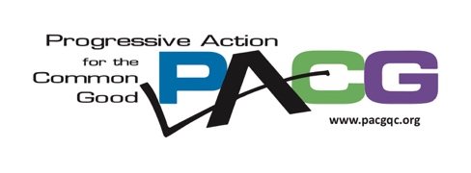

Davenport NAACP Unit #4019
PO Box 3661
Davenport, Iowa 52803

May 27, 2021

Dear Friend,

Please join us for an important training that we are co-sponsoring to bring to the Quad Cities. Race, Adolescence and Trauma will be a daytime Zoom webinar on Tuesday, June 22nd at 12:00 pm. Our presenter, Professor Kristin Henning, is a Blume Professor of Law, Georgetown Law, and the Director of the Juvenile Justice Clinic and Initiative.

This workshop is designed to help juvenile justice actors and constituents better address the impact of racial bias and policing on adolescent development, and to develop strategies to reduce the harm of racial trauma and disparities.
Racial disparities have been documented at multiple decision-making points across the juvenile legal service continuum. For many, the daily discriminatory and unnecessary encounters with police is overwhelming and traumatic. In this interactive workshop, participants will become familiar with research on racial bias, adolescent development, trauma, and stereotype threat. Participants will be challenged to understand how biases impact decision-making from arrest through disposition, assess common microaggressions, and learn how to interrupt them to prevent further racial trauma to children and families.
Program participants will:
1. Develop shared language and understanding of concepts such as racial bias, trauma, and stereotype threat.
2. Understand the traumatic effects of policing on adolescents and their families.
3. Discuss strategies for addressing racism in the child-serving network.

A partnership between the Juvenile Justice Coalition of the Quad Cities, LULAC Council 10, Davenport NAACP, One Human Family QCA, Progressive Action for the Common Good and the Unitarian Universalist Congregation of the Quad Cities is sponsoring this event.

Registration is required for this free webinar: https://us02web.zoom.us/webinar/register/WN_u2vrnNX3REW-ZLpyt29xew

A follow-up session at 7 p.m. Tuesday, July 6, will allow us to begin working on needed local changes. Registration for that meeting will be available after the webinar.

Contact Michael Guster at 563-343-7655 or gusterm@msn.com for more information.

