SUSTAINABILITY INITIATIVES
AT A GLANCE

- All new infrastructure designed to USGBC LEED standards
Operations and Maintenance Center (2014 LEED Gold pending) features:

  - 1,344 solar panels supply a portion of the building’s electrical needs
  - 32 solar panels supply all hot water needs
  - Bus wash with state of the art water reclamation
  - Energy recovery system, radiant floor slabs
  - Daylighting, occupancy controlled lighting, low VOC carpets, paints, adhesives, and composite materials
  - Bioswales to control storm water runoff
  - CNG fueling system and battery electric bus charging stations

District Station (2015 LEED Gold certified) features:
  - Solar Panel Roof
  - Occupancy Controlled Lighting
  - Re-use of water runoff

- Mixed-fleet of alternative fuel vehicles including clean-burning diesel, (1998), compressed natural gas (2002), and battery electric technology (2018), hybrid electric paratransit vans (2010), and bio-diesel (ferryboats)

- Public Relations campaigns and key community partnerships to support sustainability efforts (John Deere, MidAmerican Energy)

- American Public Transportation Association Sustainability Commitment

- Find videos on the Operations Maintenance Center, Battery Electric buses, and more on YouTube: MetroQC

SUSTAINABILITY INITIATIVES –MESSAGING

2002 CNG BUS MESSAGING
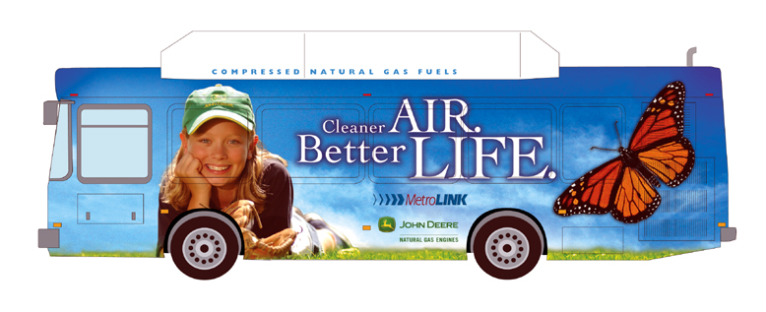

2018 ELECTRIC BUS MESSAGING
2009 CNG BUS MESSAGING

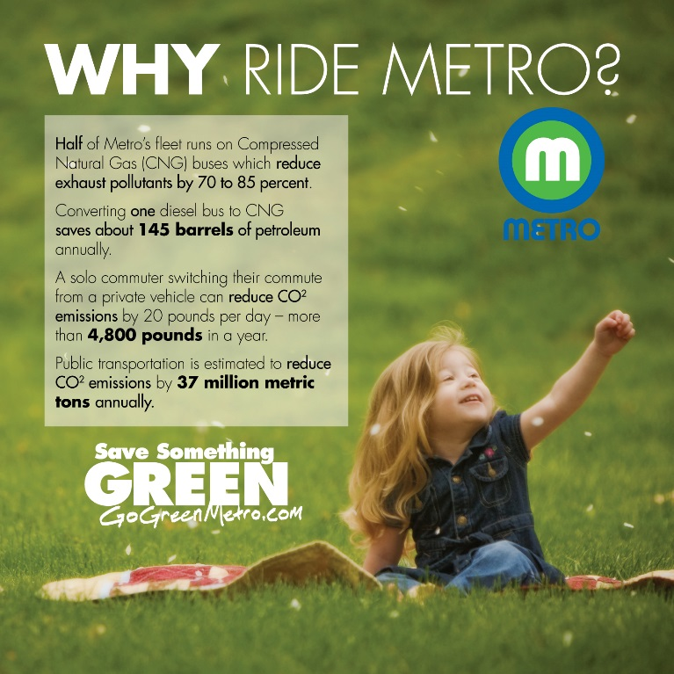

SUSTAINABILITY INITIATIVES –PROJECTS

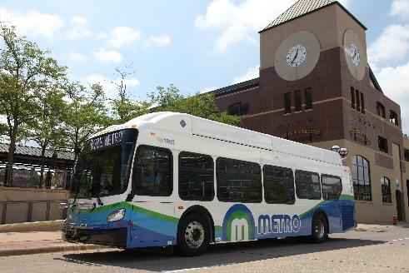
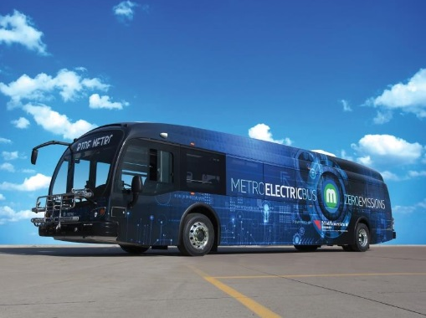
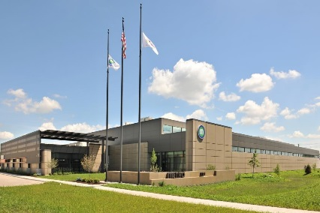
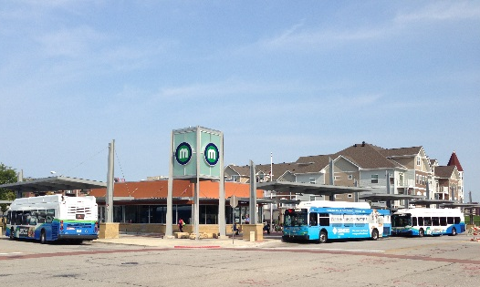
2018 New Flyer CNG Bus
2018 Proterra Battery Electric Bus
2015 LEED Gold Certified District Station
2014 LEED Gold Certified (Pending)
Operations and Maintenance Center

